

Jordan General Motors

Networking Report



January 31, 2023

ENG. ISRAA SAADEH

MARAM ALASSAF

**Part One:**

1. **Computer Networks:** A computing network is a collection of connected devices, such as computers, routers, switches, and servers connected together to share and exchange information. These devices are connected using physical wires.

* **Network Types:**

1. **Wide Area Network (WAN):** It is a type of computer network that spans a wide geographic area, such as cities, countries, or even the world. WANs are typically made by connecting multiple LANs to, allowing from different LANs to communicate with each other.

**The main usage for WAN:** To connect LANs in different geographical locations so that they send and receive information. WANs are often used by businesses with multiple locations, branches, or offices. **For example, in my project, I used the WAN computer network to connect different branches of the company all over Jordan.**

**The benefits of WAN computer network include:**

1. Communication between different locations.
2. WAN covers a large geographical area.
3. Allowing remote access to other branches without the need to travel.
4. It supports the global market and global business.

**The constraints of WAN computer network include:**

1. Cost, WANs often require specialized hardware and software.
2. Security, WANs have lower security compared to LAN and MAN due to wider coverage and the use of more technologies.
3. Latency, data may take longer to travel over a WAN than over a LAN.

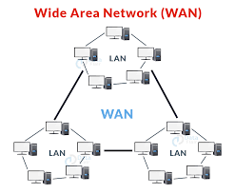

1. **Local Area Network (LAN):** It is a type of computer network that connects devices, such as computers, servers, and printers, in a limited geographical area, such as a home, office, or building.

**The main usage for LAN:** Is that it can share information, files, and internet connection within a limited area. LANs are often used in small or medium-sized businesses. **In my project, I used the LAN computer network for the branches.**

**The benefits of a LAN computer network include:**

1. Cost, LAN computer network does not cost too much unlike a WAN computer network.
2. High-speed communication and data transfer between devices.
3. More secure, it is easy to set up a security protocol to prevent unauthorized users to access the network.
4. It is easy to control and manage an entire LAN.

**The constraints of a LAN computer network include:**

1. Limited geographical coverage, as devices can only communicate within the same LAN’s coverage area.
2. A virus can be spread more easily.
3. A constant need for an upgrade.

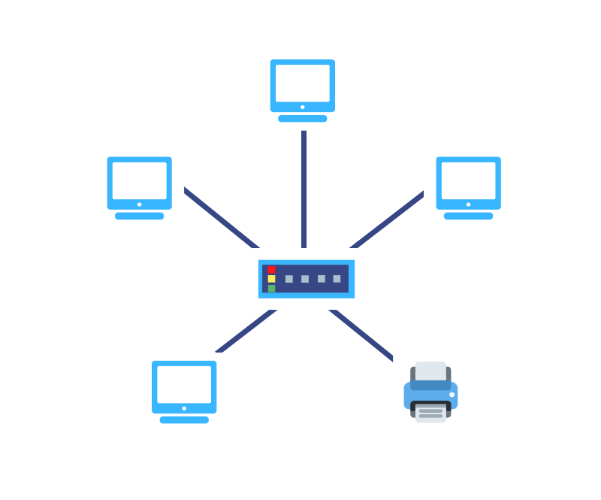

1. **Metropolitan Area Network (MAN):** It is a type of computer network that spans a larger geographical area than a LAN, such as an entire city or campus. MANs are made by connecting multiple LANs together. Thus, MANs are larger than LANs, but smaller than a WAN.

**The main use for MAN:** Connecting LANs within a metropolitan area, allowing devices and users on different LANs to communicate with each other. This can be used in organizations with multiple locations within a city.

**The benefits of a MAN computer network include:**

1. Enabling communication and collaboration between multiple LANs within a metropolitan area.
2. It is more comprehensive than a LAN and offers greater security than a WAN.
3. The cost of a MAN is lower than a WAN since it requires fewer resources.

**The constraints of a MAN computer network include:**

1. The costs are higher than those in a LAN.
2. Latency, as data may take longer to travel over a MAN than over a LAN.
3. Because this network comprises multiple LANs, it is difficult to keep hackers out.
4. **Personal Area Network (PAN):** It is a type of computer network that connects devices that are close to a person, typically within a range of a few meters.

**The main use for PAN:** Toconnect personal devices such as smartphones, laptops, tablets, and personal assistants to share information and resources such as files, and internet connection.

**The benefits of a PAN computer network include:**

1. No need for extra cables or wires.
2. You can connect to any devices at a time.
3. Affordable cost.

**The constraints of a MAN computer network include:**

1. Interfaces with radio signals.
2. PAN has a limited range.
3. PAN uses microwave signals in some digital devices which have an effect on the human body.
4. **Physical Network topologies:** These refer to the physical layout of the devices and connections in a computer network. This includes the way in which devices, such as computers, servers, and routers are connected to each other.
5. **WAN Physical Topologies:**

* **Point-to-Point Topology:** In this topology, each device in the network is connected to only one other network.

It is widely used in WAN connections, for example, to connect routers and switches together.

* **Hub and Spoke:** A central site interconnects branch sites using point-to-point. The central site is called a hub and the branch site is called a spoke. Also, communication between two spokes always travels through the hub.
* **Full Mesh:** In this topology, each device in the network is directly connected to other devices. This means that the packet has multiple paths to travel to the destination.

1. **LAN Physical Topologies:**

* **Ring Topology:** It is called ring topology because devices are connected in a circular chain. In this network, every device has exactly two neighboring devices for communication, which means that the packet has two different paths to reach the destination.
* **Star Topology:** In the star topology, all devices are connected with the help of a central hub or switch. The hub or switch acts as a central point for communication between devices. It is most popular on LAN networks as they are inexpensive and easy to install.
* **Bus Topology:** Bus topology uses a single cable that connects all the devices together. This central cable acts as a spine for the entire network.

1. **Comparison between Mesh and Star physical topologies:**

|  |  |  |
| --- | --- | --- |
|  | **Mesh** | **Star** |
| **Connectivity** | Each device is connected to multiple other devices | Each device is connected to a central hub or switch. |
| **Cost** | High | Low |
| **Security** | High, data can be sent via multiple paths. | Medium, as the central hub, can be security congestion. |
| **Used for** | High-availability networks where multiple paths for data to travel are needed. | Small networks where devices are in close proximity to each other. |

1. **The network topology used in my project:**

* **WAN:** To connect the routers together I used the Mesh topology, where every packet has 3 different paths.
* **LAN:** I used the star topology, where all end devices are directly connected with a switch.

1. **Logical Networking Protocols:**

* **Token Ring Protocol:**
* https://media.geeksforgeeks.org/wp-content/uploads/token-1.pngA token ring is a communication protocol for a local area network (LAN) by which all devices or stations are connected in a ring topology, data travels around the network in a specific order, with each device taking turns to transmitting and receiving data. This topology uses a special three-byte frame called a “token” that moves around a ring, the device that holds the token is the only one that can transmit data on the network. It also uses a token-passing passing protocol, which means that a machine can only access the network if it controls the Token; this prevents collisions because only one machine can access the network at any given time.
* **Ethernet Protocol:** Ethernet is the most widely used LAN technology, which is defined under IEEE standards 802.3, it operates at the physical and data link layers of the OSI model. To manage network access and prevent data collisions, it employs a method known as carrier sense multiple access with collision detection (CSMA/CD). This means that before transmitting data, network devices listen for a clear signal, and if a collision is detected, they wait for a random period of time before attempting to transmit again.
* **Ethernet advantages:**

1. simple to understand, implement, and maintain, and allows for low-cost network implementation.
2. **Speed:** Ethernet provides significantly faster performance. This is because Ethernet is a one-to-one connection. Speeds of up to 10 Gigabits per second (Gbps) or even 100 Gigabits per second (Gbps) are possible as a result.
3. **Network Protocols:** A set. of rules and standards that determine the communication between devices in the same network.

**Examples of common network protocols:**

1. **Hyper Text Transfer Protocol Secure (HTTPS):** Used for transferring data over the web. It uses web browsers. Data in HTTPS is encrypted by adding a TLS layer or SSL unlike HTTP data is sent as clear text.

**Port Number:** 443.

1. **File Transfer Protocol (FTP):** Allows users to transfer files (reports, images, and documents).

**Port Number:** 20 (Sending data) / 21 (controlling data).

1. **Domain Name Server (DNS):** Mapping or translating domain names into IP addresses that a computer can understand.

**Port Number:** 53.

1. **Dynamic Host Configuration Protocol (DHCP):** Protocol used to dynamically assign an IP address to devices, so they can communicate with each other.

**Port Number:** 67 (Server) / 68 (Client).

1. **Simple Mail Transfer Protocol (STMP):** Used for sending email messages between devices.

**Port Number:** 25.

1. **Post Office Protocol (POP3):** Used for receiving email messages (cut).

**Port Number:** 110.

1. **Internet Message Access Protocol (IMAP):** Used for receiving email messages (copy).

**Port Number:** 143.

1. **Networking Devices:**
2. **Routers:** Routers are one of the most common networking devices, they are responsible for connecting two or more LANs together. Basically, a router is responsible for forwarding packets, it takes the packet from the source and directs it to its right destination. Layer 3 (Network layer), is where the data is being sent between and across networks using routers.

* **There are two common types of routers:**
* **Wired Router:** connects the LANs using wired cables. This is the type that I use in my project.
* **Wireless Router:** connects LANs wirelessly without using physical cables.

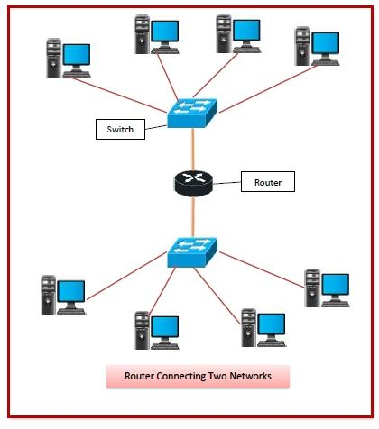

1. **Switches:** A switch is a hardware component that is responsible for connecting end devices together and transferring data packets to and from devices on a LAN. Since switches are responsible for forwarding data packets relying on MAC addresses, so It operates at layer 2 (Data Link Layer).

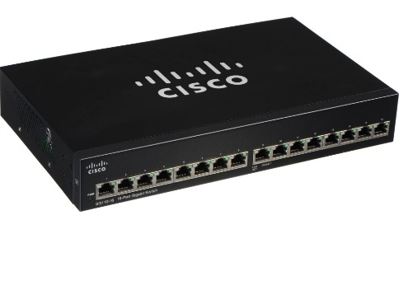

1. **Access Point:** Access points are networking devices that are responsible for providing wireless connectivity to devices. They operate on the Data Link Layer (layer 2) of the OSI model and use wireless protocols such as WiFi to provide connectivity.

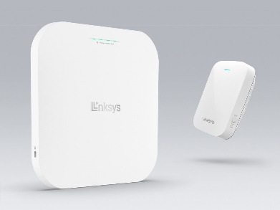

1. **Hubs:** Hub is a networking device that allows two or more devices to connect with it and communicate with each other. It works by connecting devices to a hub using Ethernet cables and then forwarding data packets between them. When a device connected to a hub sends a data packet, the hub receives the packet and then sends a copy of it to all other devices connected to the hub. This allows all connected devices to receive and process the same data. Hubs are considered a basic, older technology and have largely been replaced by switches. Hubs operate at layer 1 (physical layer).



1. 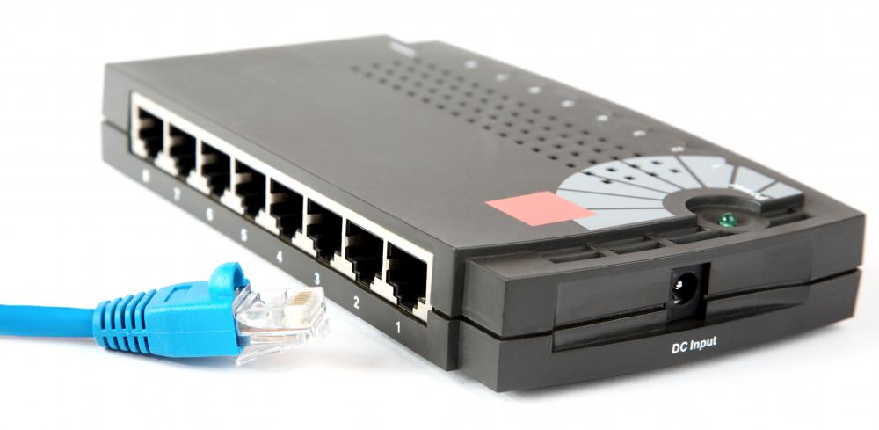**Bridge:** network bridge is a device that connects two or more networks together. It allows devices on those networks to communicate with each other as if they were on the same network. It does this by looking at the MAC addresses of the devices and forwarding data packets between the networks. It's useful for connecting two separate networks together without adding more complexity or IP addresses. Bridges operate at layer 2 (Data Link Layer).
2. **Servers Types:**

|  |  |  |  |  |
| --- | --- | --- | --- | --- |
| **Web Server** | **DNS Server** | **FTP Server** | **DHCP Server** | **Email Server** |
| The web server uses the HTTP and HTTPS protocols for browsing. It’s computer software and the underlying hardware that accepts HTTP/HTTPS requests. HTTP/HTTPS is a network protocol that is used to deliver web pages. Send a request to the server and begin communication using an HTTP/HTTPS web browser.  **Port number:**  **- HTTP: 80 / 8080**  **- HTTPS: 443** | The Domain Name System (DNS) is the Internet's phonebook. Domain names are used by humans to access information online. Web browsers communicate using Internet Protocol (IP) addresses. DNS converts domain names to IP addresses so that browsers can access Internet resources.  **Port number: 53** | A server that is used to transfer, download and upload files from one location to another over the internet using the FTP protocol.  **Port Number:**  **- FTP: 20 / 21** | A DHCP server is a protocol for dynamically assigning IP addresses to network devices. A DHCP server is a specialized server that assigns IP addresses to network devices while also providing other information such as the subnet mask, default gateway, and DNS server addresses.  **Port number:**  **-DHCP Server: 67**  **-Client: 68** | An email server is a computer system that sends and receives emails. Mail servers send and receive email using standard email protocols. For example, the SMTP protocol sends messages and handles **outgoing** mail requests. The IMAP and POP3 protocols receive messages and are used to process **incoming** mail.  **Port number:**  **-SMTP: 25**  **-IMAP: 143**  **-POP: 110** |

* **Web Servers:**
* **Operating system used in the web server:**

The web server uses different types of operating systems such as Windows and Linux to run and manage a certain website. Linux is popular because it’s free, stable, and secure. However, Windows are also commonly used specifically in an environment where most computers are already using Windows OS.

* **Hardware specification:**

1. CPU: A high-performance CPU is essential because it must handle multiple requests and processes at the same time.
2. **RAM:** A web server should have enough RAM to handle the number of requests as well as the size of the website.
3. **Hard drive (storage):** A web server should have enough storage space to hold the website's files as well as any associated databases. SSDs are preferred because of their faster read and write speeds.

* **Infrastructure needs:**

1. **Network infrastructure:** A web server must be linked to the internet via a fast and dependable network connection.
2. **Infrastructure for cooling: A** web server overheats, an appropriate cooling is required to prevent overheating and make sure the server's stability.
3. **Power infrastructure:** A web server requires a consistent and dependable power source, as well as backup power in the event that the power might cut off accidentally.

* **The cost for the web server:** For the network, I implemented the cost is important because it depends on the website performance and security requirements.
* In order to optimize the performance of a web server we can implement load balancers. Load balancing spreads incoming traffic across multiple servers, reducing the load on any single server and improving overall web server performance.
* **DNS Servers:**
* **Operating system used in the DNS server:** DNS servers can operate on a variety of operating systems, including Windows, Linux, and Unix.

1. **Linux:** Because of its stability, security, and flexibility, Linux is a popular choice for DNS servers.
2. **Windows Server:** Windows Server is also commonly used for DNS servers and includes a DNS server software called Microsoft DNS Server built in.

* **Hardware specification:**

1. **CPU:** Because a DNS server will be handling a large number of DNS requests, a high-performance CPU is essential.
2. **Memory:** A DNS server requires enough memory to store DNS records; the more memory, the better the server's performance.
3. **Network:** A DNS server requires a high-speed network connection because it handles large amounts of data transfer.

* **Infrastructure needs:**

1. **Network connectivity:** In order to handle a large number of DNS requests and transfer large amounts of data, a DNS server requires a reliable and high-speed network connection.
2. **Power supply:** A DNS server requires a dependable power supply to remain online and ready to handle DNS requests.
3. **Monitoring and logging:** To track performance, identify possible problems, and troubleshoot issues, a DNS server should be monitored and logged.

* **The cost for the DNS server:** the cost of a DNS server depends on the amount of traffic and number of DNS records.
* In order to optimize the network performance of our DNS server we can do regular maintenance for our DNS server such as updating the software and troubleshooting the issues. Also, a DNS server should be properly sized to handle the number of quires and traffic.
* **FTP server:**
* **FTP server operating system:** there are different operating systems that can be used to run an FTP server, such as Windows, Linux, and Unix. FileZilla Server is a popular FTP server software for Windows.
* **Hardware specification:** A server with a fast CPU, enough RAM, and a large storage capacity can handle more traffic and data transfer than a lower-spec server.
* **Infrastructure needs:** theyinclude a dependable and fast network connection, a stable power supply, adequate cooling, and physical security. Remote management capabilities, as well as a backup and disaster recovery plan, are also required for server maintenance.
* **Cost:** the cost of an FTP server is determined by the hardware and software used, as well as the level of support and maintenance required.
* **Optimizing network performance:** You can use load balancing and redundancy to improve the performance of an FTP server.
* **DHCP server:**
* **DHCP server operating system:** DHCP servers can run on a variety of operating systems, including Windows, Linux, and Unix. Microsoft DHCP Server is a popular DHCP server software for Windows.
* **Hardware specification:** DHCP server will vary depending on the number of clients connecting and the amount of traffic that the server will handle.
* **Infrastructure needs:** include a dependable and fast network connection, a stable power supply, adequate cooling, and physical security.
* **The cost for the DHCP server:** For the network that I implemented the cost is important because it depends on a reliable and fast network connection and physical security requirements.
* **Optimizing network performance:** You can use load balancing and redundancy to improve the performance of a DHCP server.

1. **Inter-dependences of hardware:**

A workstation is a computer that is specifically designed for scientific or technical applications and is intended to be used by only one person at a time. It is usually connected to a working local area network and runs a multi-user operating system. It is a computer designed to outperform a PC because PCs can be used independently of mainframes, implying they have their own applications that are installed and stored on their hard drives.

**The interdependence of workstation hardware with relevant networking software:**

The workstation's operating system serves as the foundation for its software and must be compatible with the network's operating systems and software. This ensures that the workstation can communicate with other network devices, access shared resources, and use network services**.**

The network interface card (NIC) is the hardware component that connects the workstation to the network. To ensure proper communication, the NIC's driver software must be compatible with the workstation's operating system and network protocols.

**Part Two:**

1. **Step-by-Step Plan:** I designed 7 LANs and a router for each LAN except for the HQ and the datacenter which have 2 LANs in the same router. For each LAN we have 2 PCs, 1 Access point, and 1 printer. Datacenter LAN has 3 PCs and a server that includes all the required services.

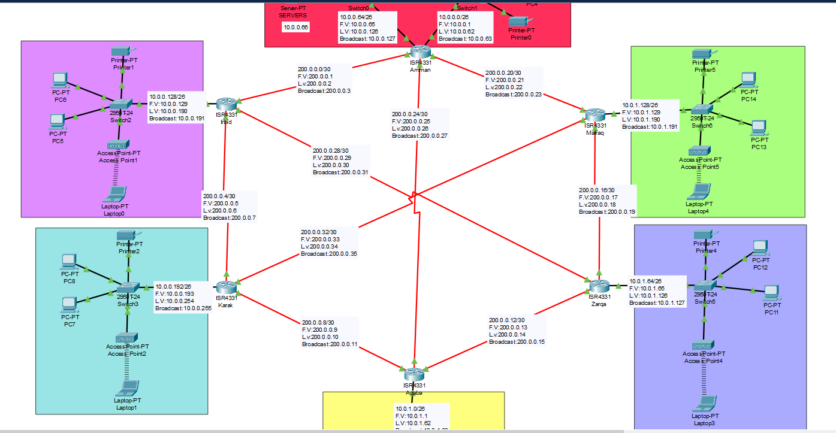

1. **Subnetting Tables:**

* **LAN subnetting table:**

|  |  |  |  |  |
| --- | --- | --- | --- | --- |
| **NETWORKS** | **NID** | **F.V** | **L.V** | **BROADCAST** |
| **AMMAN HQ** | 10.0.0.0 /26 | 10.0.0.1 | 10.0.0.62 | 10.0.0.63 |
| **AMMAN DATACENTER** | 10.0.0.64 /26 | 10.0.0.65 | 10.0.0.126 | 10.0.0.127 |
| **IRBID** | 10.0.0.128 /26 | 10.0.0.129 | 10.0.0.190 | 10.0.0.191 |
| **KARAK** | 10.0.0.192 /26 | 10.0.0.193 | 10.0.0.254 | 10.0.0.255 |
| **AQABA** | 10.0.1.0 /26 | 10.0.1.1 | 10.0.1.62 | 10.0.1.63 |
| **ZARQA** | 10.0.1.64 /26 | 10.0.1.65 | 10.0.1.126 | 10.0.1.127 |
| **MAFRAQ** | 10.0.1.128 /26 | 10.0.1.129 | 10.0.1.190 | 10.0.1.191 |

* **WAN subnetting table:**

|  |  |  |  |  |
| --- | --- | --- | --- | --- |
| **NETWORK** | **NID** | **F.V** | **L.V** | **BROADCAST** |
| **AMMAN – IRBID** | 200.0.0.0 /30 | 200.0.0.1 | 200.0.0.2 | 200.0.0.3 |
| **IRBID – KARAK** | 200.0.0.4 /30 | 200.0.0.5 | 200.0.0.6 | 200.0.0.7 |
| **KARAK – AQABA** | 200.0.0.8 /30 | 200.0.0.9 | 200.0.0.10 | 200.0.0.11 |
| **AQABA – ZARQA** | 200.0.0.12 /30 | 200.0.0.13 | 200.0.0.14 | 200.0.0.15 |
| **ZARQA – MAFRAQ** | 200.0.0.16 /30 | 200.0.0.17 | 200.0.0.18 | 200.0.0.19 |
| **MAFRAQ – AMMAN** | 200.0.0.20 /30 | 200.0.0.21 | 200.0.0.22 | 200.0.0.23 |
| **AMMAN – AQABA** | 200.0.0.24 /30 | 200.0.0.25 | 200.0.0.26 | 200.0.0.27 |
| **IRBID – ZARQA** | 200.0.0.28 /30 | 200.0.0.29 | 200.0.0.30 | 200.0.0.31 |
| **KARAK – MAFRAQ** | 200.0.0.32 /30 | 200.0.0.33 | 200.0.0.34 | 200.0.0.35 |

* **Gateways addresses for each network:**

|  |  |  |  |  |  |  |
| --- | --- | --- | --- | --- | --- | --- |
| **Amman HQ** | **Amman Datacenter** | **Irbid** | **Karak** | **Aqaba** | **Zarqa** | **Mafraq** |
| 10.0.0.1 | 10.0.0.65 | 10.0.0.129 | 10.0.0.193 | 10.0.1.1 | 10.0.1.65 | 10.0.1.129 |

* **Printers IP addresses are set statically:**

|  |  |  |  |  |  |
| --- | --- | --- | --- | --- | --- |
| **Amman HQ printer** | **Irbid printer** | **Karak printer** | **Aqaba Printer** | **Zarqa printer** | **Mafraq printer** |
| 10.0.0.2 | 10.0.0.130 | 10.0.0.194 | 10.0.1.2 | 10.0.1.66 | 10.0.1.130 |

* **The server IP address is set statically:**

**Server’s address: 10.0.0.66**

* **For the other end devices like (PCs) IP addresses are set dynamically using the DHCP server.**

1. **Routers:**
2. **Router Amman HQ and Datacenter:**

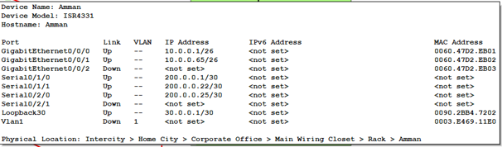

|  |  |  |  |
| --- | --- | --- | --- |
| **Interfaces Names** | **IP address** | **Protocol used** | **Password** |
| **Gig0/0/0**  **Gig0/0/1**  **Se0/1/0**  **Se0/1/1**  **Se0/2/0**  **Loopback30** | **10.0.0.1 /26**  **10.0.0.65 /26**  **200.0.0.1 /30**  **200.0.0.22 /30**  **200.0.0.25 /30**  **30.0.0.1 /30** | **RIP** | **1234** |

1. **Router Irbid:**

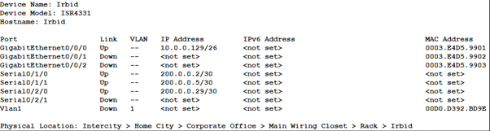

|  |  |  |  |
| --- | --- | --- | --- |
| **Interfaces Names** | **IP address** | **Protocol used** | **Password** |
| **Gig0/0/0**  **Se0/1/0**  **Se0/1/1**  **Se0/2/0** | **10.0.0.129 /26**  **200.0.0.2 /30**  **200.0.0.5 /30**  **200.0.0.29 /30** | **RIP** | **1234** |

1. **Router Karak:**

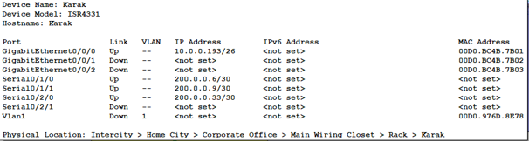

|  |  |  |  |
| --- | --- | --- | --- |
| **Interfaces Names** | **IP address** | **Protocol used** | **Password** |
| **Gig0/0/0**  **Se0/1/0**  **Se0/1/1**  **Se0/2/0** | **10.0.0.193 /26**  **200.0.0.6 /30**  **200.0.0.9 /30**  **200.0.0.33 /30** | **RIP** | **1234** |

1. **Router Aqaba:**

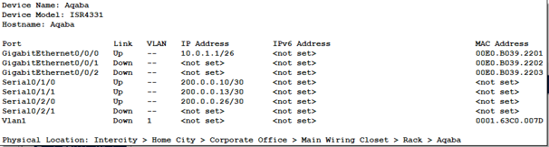

|  |  |  |  |
| --- | --- | --- | --- |
| **Interfaces Names** | **IP address** | **Protocol used** | **Password** |
| **Gig0/0/0**  **Se0/1/0**  **Se0/1/1**  **Se0/2/0** | **10.0.1.1 /26**  **200.0.0.10 /30**  **200.0.0.13 /30**  **200.0.0.26 /30** | **RIP** | **1234** |

1. **Router Zarqa:**

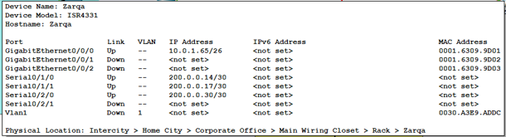

|  |  |  |  |
| --- | --- | --- | --- |
| **Interfaces Names** | **IP address** | **Protocol used** | **Password** |
| **Gig0/0/0**  **Se0/1/0**  **Se0/1/1**  **Se0/2/0** | **10.0.1.65 /26**  **200.0.0.14 /30**  **200.0.0.17 /30**  **200.0.0.30 /30** | **RIP** | **1234** |

1. **Router Mafraq:**

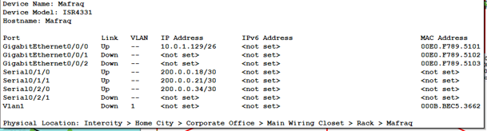

|  |  |  |  |
| --- | --- | --- | --- |
| **Interfaces Names** | **IP address** | **Protocol used** | **Password** |
| **Gig0/0/0**  **Se0/1/0**  **Se0/1/1**  **Se0/2/0** | **10.0.1.129 /26**  **200.0.0.18 /30**  **200.0.0.21 /30**  **200.0.0.34 /30** | **RIP** | **1234** |

1. **Detailed information about the servers:**

* **For the servers I used one server for all the services.**
* **The main reason why I used one server to do all the services is to cut down the expenses for the company, by using one server we can save on hardware and maintenance costs.**
* **Servers may go down at any time so having one server can make it easier to manage, understand and troubleshoot.**

|  |  |  |  |  |
| --- | --- | --- | --- | --- |
| **Web Server** | **DNS Server** | **FTP Server** | **DHCP Server** | **Email Server** |
| The web server uses the HTTP and HTTPS protocols for browsing. It’s computer software and the underlying hardware that accepts HTTP/HTTPS requests. HTTP/HTTPS is a network protocol that is used to deliver web pages. Send a request to the server and begin communication using an HTTP/HTTPS web browser.  **Port number:**  **- HTTP: 80 / 8080**  **- HTTPS: 443** | The Domain Name System (DNS) is the Internet's phonebook. Domain names are used by humans to access information online. Web browsers communicate using Internet Protocol (IP) addresses. DNS converts domain names to IP addresses so that browsers can access Internet resources.  **Port number: 53** | A server that is used to transfer, download and upload files from one location to another over the internet using the FTP protocol.  **Port Number:**  **- FTP: 20 / 21** | A DHCP server is a protocol for dynamically assigning IP addresses to network devices. A DHCP server is a specialized server that assigns IP addresses to network devices while also providing other information such as the subnet mask, default gateway, and DNS server addresses.  **Port number:**  **-DHCP Server: 67**  **-Client: 68** | An email server is a computer system that sends and receives emails. Mail servers send and receive email using standard email protocols. For example, the SMTP protocol sends messages and handles **outgoing** mail requests. The IMAP and POP3 protocols receive messages and are used to process **incoming** mail.  **Port number:**  **-SMTP: 25**  **-IMAP: 143**  **-POP: 110** |

* **Services Configuration:**
* **Web Service (HTTPS):**

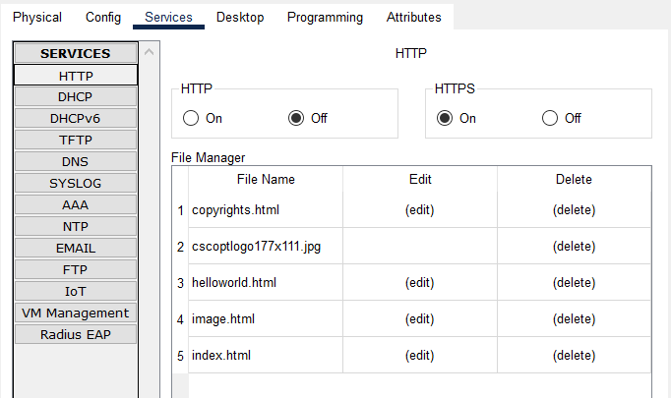

* **DNS Service:**

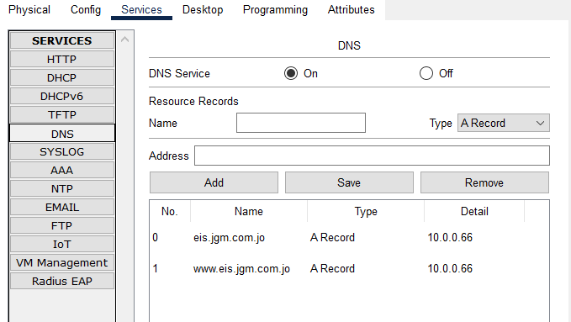

* **FTP Service:** 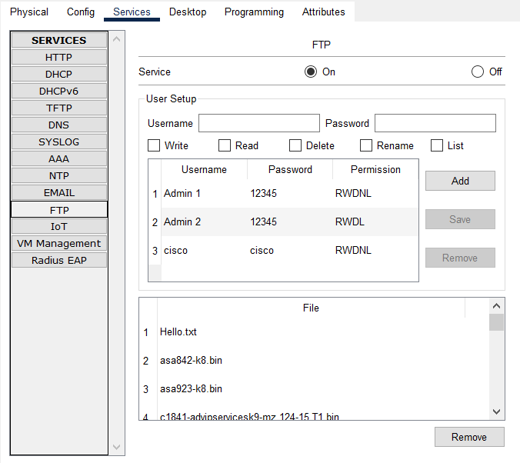
* **Email Service:**

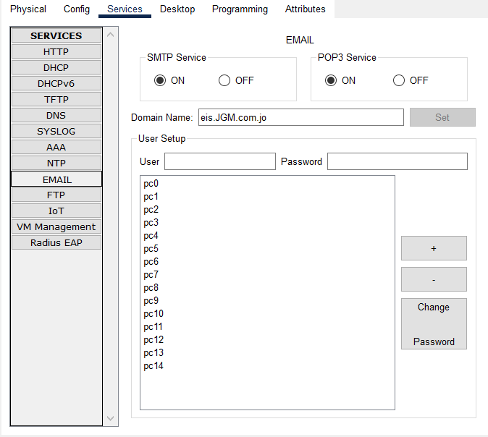

* **DHCP Service:**

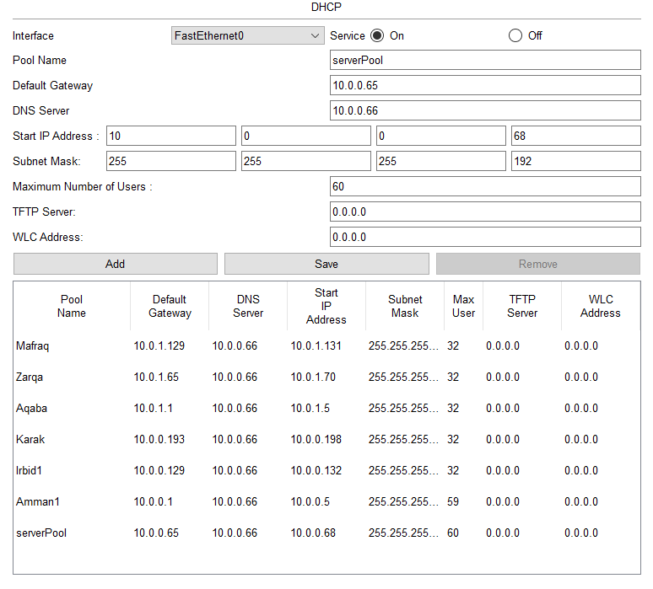

Please note that I used all 5 services in one server with static IP address: 10.0.0.66, and I’ve mentioned before the reason why I used all 5 services in one server.

* **Test Plan:**

|  |  |  |
| --- | --- | --- |
| **Test** | **How to test** | **Expected result** |
| **Web Service** | Firstly, open our project on packet tracer, double click on the server, go to the services, then to HTTPS and we must make sure that the HTTP protocol is turned off, After that, we should give a domain name from the DNS service so users can access the web using this URL (https://eis.JGM.com.jo/ ).  Then go to any pc, to the web browser option then put the URL. | Access successfully to the web page. |
| **DHCP Service** | Enter any pc or laptop, then go to the desktop option, then set a DHCP IP address. | DHCP request successful message. |
| **FTP Server** | From a pc, go to the command prompt and write the command ftp (IP address for FTP server). | A message that tells us to enter a username, so it can transfer files. |
| **Email** | Go to any pc and add the sender’s information, compose an email, then press the send button. | A message that tells us that the email was sent successfully. |
| **PING** | Go to the command prompt of any pc and then type the command ping followed by the destination IP address. | We expect to see a reply message. |
| **IP Route** | Go to CLI in the router and enter the privilege mode and type the command show ip route | We expect to see the routing table for the directly connected networks and remotely connected networks. |

* **Maintenance Plan:**

1. Data backups.
2. Malware protection and network scans.
3. Up-to-date network defense, such as traffic-managing firewalls.
4. Power checks.
5. Check the connectivity daily between routers, servers, pcs, and switches.
6. Maintain software and computer tools, as well as their work continuity.

**Part Three:**

1. **Implement a networked system:**



1. **Conduct verification:**

**Ping: pc11 -> pc6**

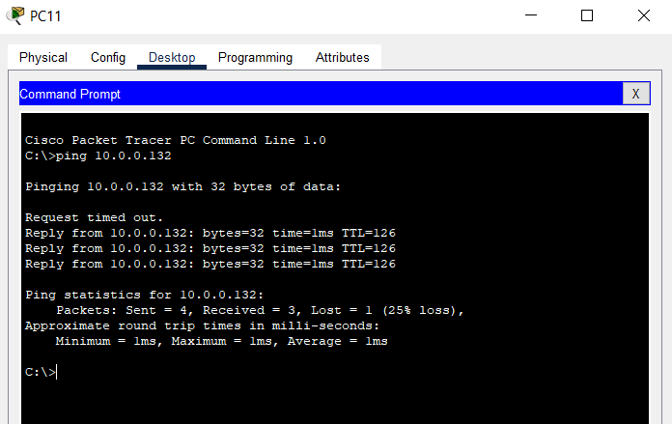

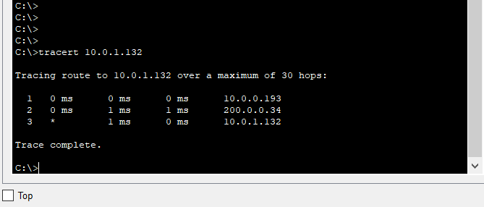 **Tracert: PC 7 to PC 14**

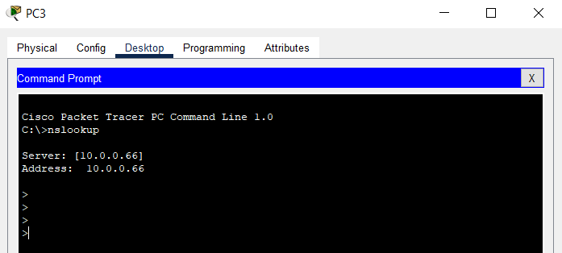**Nslookup:**

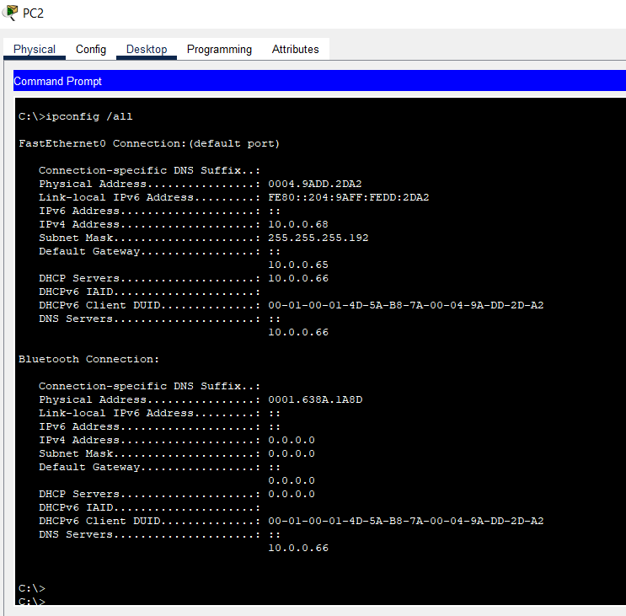**IP config / all:**

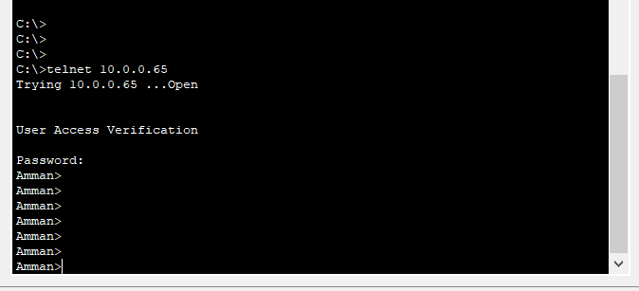**Telnet:**

**Printer connectivity:**

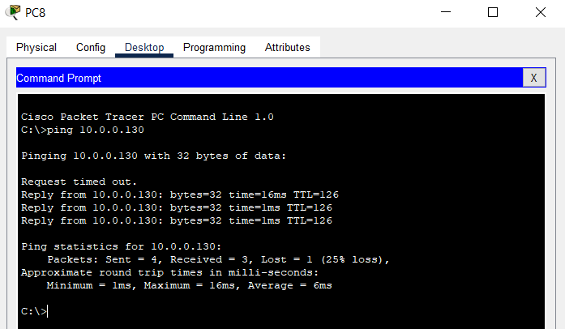

1. **Test the result for the installed services:**

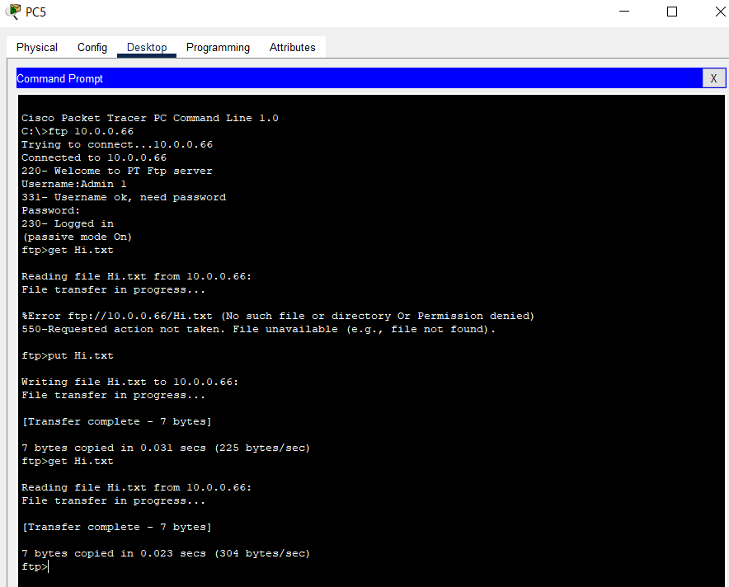**FTP**

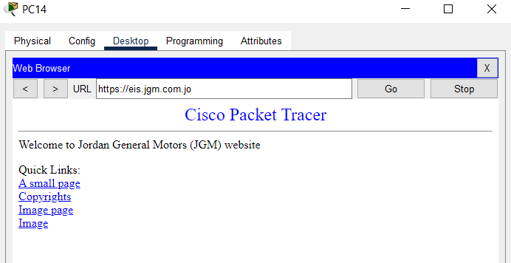 **Web service:**

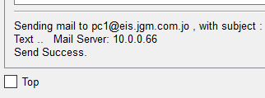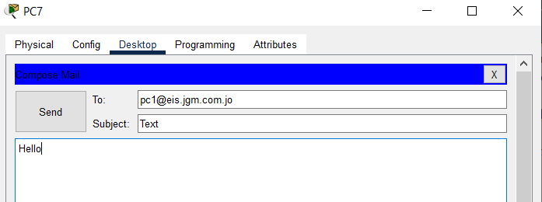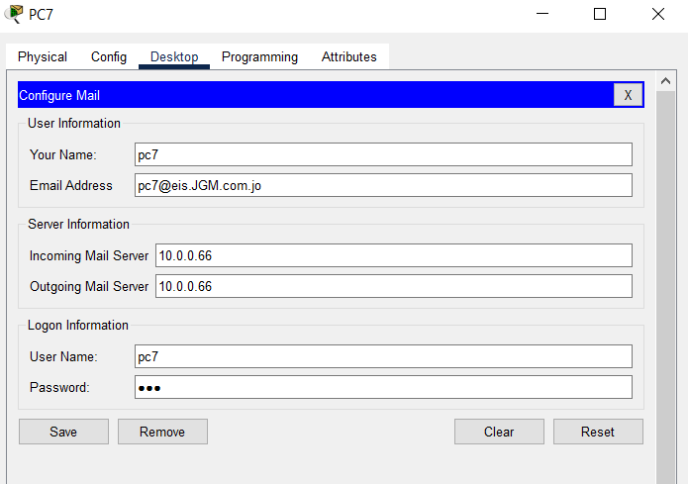 **Mail Server**

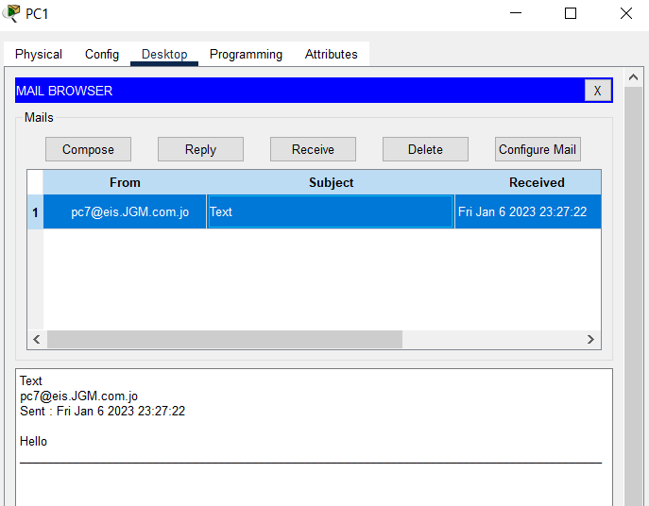

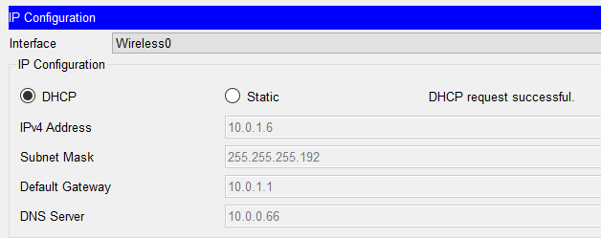**DHCP**

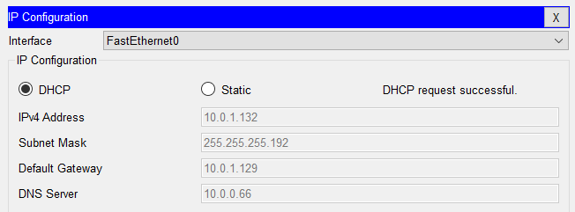

1. **Recommended potential enhancements:**
2. **Scalable network architecture:** The network should be designed so that it can easily expand and accommodate new devices while maintaining performance.
3. **Dynamic IP allocation:** The system should have the capability to dynamically assign IP addresses to new devices as they join the network.
4. **Network security:** As the number of devices on a network grows, so does the risk of security breaches. The system should be able to protect data transmission between devices and prevent unauthorized access.
5. **Upgrade and update firmware and software:** Nothing stays the same for long in technology; there will always be changes, so all component software and firmware involved will need to be updated as new updates are rolled out. While your office chores increase significantly every day in an effort to meet new customer demands, if you have been using software for too long without making any significant changes to it, you will most likely notice that tasks are not being completed as quickly as they once were.
6. **upgrades and security requirements:** theseare essential to ensure that the networked system can handle the increasing number of devices and communication methods and that the data transmitted over the network is secure and protected.
7. **To conclude:** I designed an efficient network system for Jordan General Motors (JGM), I used the packet tracer to simulate the network before implementing it. The network contains a total of 6 routers for the company’s branches 7 LANs 2 for Amman (HQ & Datacenter) and another 5 for the branches. For the physical topology, I used the Mesh topology for the WAN, and I used the star topology for the LANs. The main reason why I used the Mesh topology is that every router has a total of 3 paths.

For the dynamic routing protocols, I used RIP routing protocol, the main reason why I used RIP instead of OSPF is that I wanted to be unique because all my colleagues used OSPF. RIP is a relatively simple routing protocol to implement and maintain. It uses a small message format and simple algorithms, making it easy to understand and troubleshoot, loop prevention, RIP uses a maximum hop count of 15 to prevent routing loops, which can occur in large or complex networks. Supports for VLSMs: RIP version 2 (RIPv2) supports Variable-Length Subnet Masks (VLSMs), which allows for more efficient use of IP address space in a network.

* **References:**
* *What Is a Computer Network? Definition, Objectives, Components, Types, and Best Practices*. [online] Spiceworks. Available at: <https://www.spiceworks.com/tech/networking/articles/what-is-a-computer-network/>.
* *Advantages of WAN | disadvantages of WAN*. [online] Available at: <https://www.rfwireless-world.com/Terminology/Advantages-and-disadvantages-of-WAN.html>.
* *ECSTUFF4U for Electronics Engineer*. [online] Available at: <https://www.ecstuff4u.com/2018/05/advantages-and-disadvantages-of-local.html>.
* *What is Metropolitan Area Network (MAN)?* [online] Available at: <https://www.techopedia.com/definition/8238/metropolitan-area-network-man>.
* *What is Physical Topology?* [online] Available at: <https://www.techopedia.com/definition/4794/physical-topology#:~:text=Physical%20topology%20refers%20to%20the>.
* *COMMON PHYSICAL OF WAN TOPOLOGIES - Networking 2498*. [online] Available at: <https://sites.google.com/site/networking2498/network-fundamentals/commonphysicalofwantopologies>.
* *Cloudflare*. [online] Cloudflare. Available at: <https://www.cloudflare.com/learning/dns/what-is-dns/>.
* *What Is A Router And How Does It Work?* [online] Available at: <https://www.comms-express.com/blog/what-is-a-router-and-how-does-it-work/>.
* What is a network switch? Cloudflare. *Cloudflare*. [online] Available at: <https://www.cloudflare.com/learning/network-layer/what-is-a-network-switch/>.
* *What is Network Hub and How it Works?* [online] Available at: <https://www.geeksforgeeks.org/what-is-network-hub-and-how-it-works/>.
* *the Difference Between Hubs, Switches & Bridges?* [online] Available at: <https://www.globalknowledge.com/us-en/resources/resource-library/articles/what-s-the-difference-between-hubs-switches-bridges/#gref>.
* *Efficiency Of Token Ring - GeeksforGeeks*. [online] Available at: <https://www.geeksforgeeks.org/efficiency-of-token-ring/>.
* *7 Tips to Enhance Network Performance*. [online] Advanced Network Professionals. Available at: <https://www.getanp.com/blog/65/7-tips-to-enhance-network-performance.php>.
* *Types of Computer Servers and Howtransmiton*. [online] Available at: <https://www.indeed.com/career-advice/career-development/types-of-servers>.
* *Server Operating System: Server OS Types & How to Choose*. [online] Knowledge Base by phoenixNAP. Available at: <https://phoenixnap.com/kb/server-operating-system>.
* *How to Determine the Correct Size and Type of a Web Server*. [online] Available at: <https://hostadvice.com/how-to/how-to-determine-the-correct-size-and-type-of-a-web-server/#:~:text=The%20three%20main%20hardware%20components>.
* *What Is Server Infrastructure? IT Glossary|SolarWinds*.[online] Available at: <https://www.solarwinds.com/resources/it-glossary/server-infrastructure#:~:text=Server%20infrastructure%20consists%20of%20physical>
* *Why Workstation Hardware Interdependent To Networking Operating System? – LEMP*. [online] Available at: <https://lemp.io/why-workstation-hardware-interdependent-to-networking-operating-system/>.